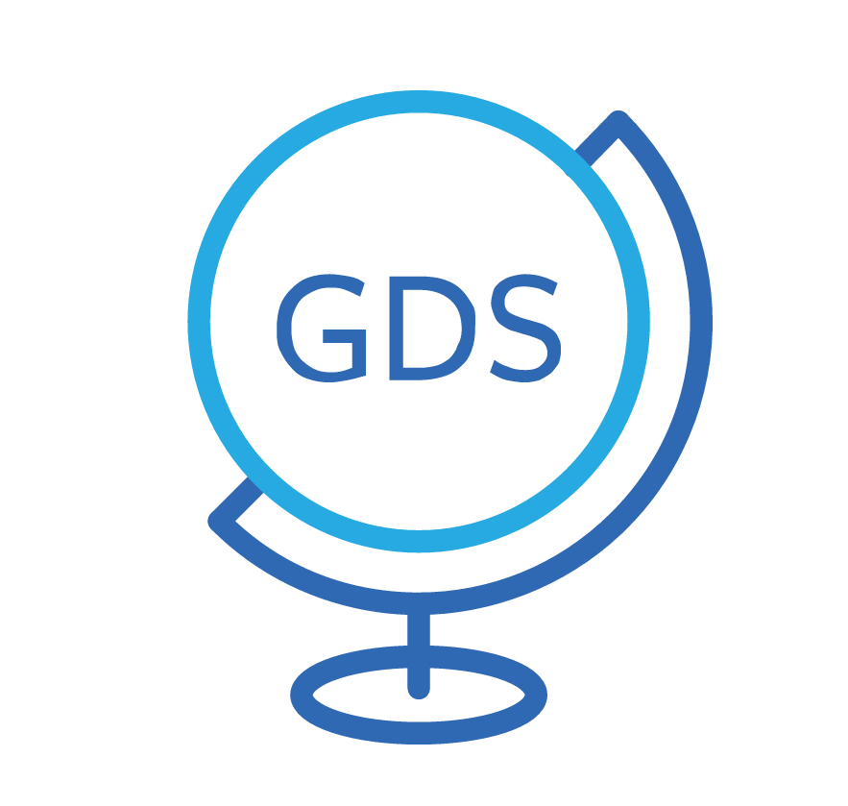
Hoteliers.com GDS Connector
Hotel Setup Form

INTRODUCTION
To open an account for your hotel in the Hoteliers.com GDS Connector (powered by reconline) we need your address, contact name and information about your room types. This form will help you to set up this information.
Important: the information of this form will only allow us to create an account for your hotel in the GDS Connector. After this, you need to complete your hotel data online in the GDS Connector (hotel amenities, sales texts, offers, prices, availabilities,...) As soon as we have created an account for your hotel you will receive your personal user name and password to login to the system and administer your data online.
Questions? If you have questions or if you need further information, please contact by phone +31 (0) 20 531 3333, via support@hoteliers.com or in a reply to your existing ticket – we are happy to assist.

HOTEL |  | Please note: Enter your sales address, not the billing address

NAME
STREET |  |  | ZIP CODE, CITY, COUNTRY
PHONE | FAX |  | E-MAIL | WEBSITE
NUMBER OF ROOMS IN TOTAL

CONTACT
NAME | POSITION | E-MAIL
 | Management
 | Reservations
 | Sales/Marketing

CURRENCY | Please enter your rate currency
ROOM TYPES
In the Hoteliers.com GDS Connector you can open an unlimited number of room types. Please consider that the more room types you open, the more work you will have to update your information (availabilities, rates, ...). That’s why we recommend you open only those room types where you have the greatest availability.
Optional: if you work with room codes (ex. DBL for double room or similar) you can also enter your own room codes to make the update of the data easier for you.
Listed below is an example on how the room description should appear:
“2 Double beds, free wi-fi, direct dial telephone, cable/satellite TV, bathroom with tub/shower, toilet, hairdryer-on request, mirror. Work table with chairs, fully furnished kitchen - stove, microwave, refrigerator, coffee/tea maker dishes.”

ROOM TYPE (max. 30 characters)  i.e. Standard double room |  | CODE i.e. DBL (max. 3 characters, letters or numbers)

ROOM DESCRIPTION (max. 600 characters) ex. 2 Double beds, free wi-fi, direct dial telephone, cable/satellite TV, bathroom with tub/shower, toilet, hairdryer-on request, mirror. Work table with chairs, fully furnished kitchen - stove, microwave, refrigerator, coffee/tea maker dishes.
STANDARD OCCUPANCY i.e. 2 | MAX. OCCUPANCY WITH ROLLAWAY |  | BED TYPE i.e. Double (or King)

ROOM TYPE (max. 30 characters) |  | CODE

ROOM DESCRIPTION (max. 600 characters)
STANDARD OCCUPANCY | MAX. OCCUPANCY WITH ROLLAWAY |  | BED TYPE

If you want to open more than 2 room types, please copy this page.

